Welcome – a ‘how to’
Promoting our churches

Presentation for Methodist Synod, 5 December 2015 by Silvia Purdie

Hands up if you want your church to grow, if you would love to welcome new people into your church fellowship?
Sadly I feel that for many of our churches, this desire has become wishful thinking, nostalgia for the good old days when lots of people visited and lots of people stayed. I wonder if our ability to look for ways to welcome new people into our churches has become limited by a lack of self confidence, an ambivalence on behalf of our people as to whether their church has anything much to offer in our changing world … which maybe reflects a sense of rejection, or fear of rejection.

I want to suggest to you that there are simple, practical things that we can do as churches that create points of connection between the inside and the outside of our churches, that significantly increase the chances that someone new will walk through our door on a Sunday morning. Having new people come, and appreciate the treasures that are real and true in our churches, this is absolutely the best way to build up the confidence of our members in who they are and what they have to share.

The first question to ask is – are we public or private? The downward cycle of church decline pulls us away from a sense of being a public place; the walls between us and the outside world get more impenetrable. I wonder if I might risk being offensive this morning and say that in my opinion our right to use our church buildings depends on our commitment to keeping them as public places of worship. If a church has become a closed clique then it should find a private place to meet and release the resource of the church building for others to make better use of.

But most of the people in the town where you live would never dream of walking through the doors of your church. Why would they?
The basic question of church growth is this -
What on earth would make someone walk through your door? I never underestimate the feat of bravery it takes to go into a strange church.
When was the last time you went into a strange church?
I dare you – go visit somewhere new. I mean, I have been to many many hundreds of churches in my time and still I never actually WANT to walk through a door for the first time. I still hear the echo of those fears – will it be weird? will I get stuck? what if no one likes me?

It is our space, and our responsibility as churches to swing our doors open wide, to create pathways into our churches. Not just the physical doors and buildings but that is a good place to start.

Let me tell you about Milson.
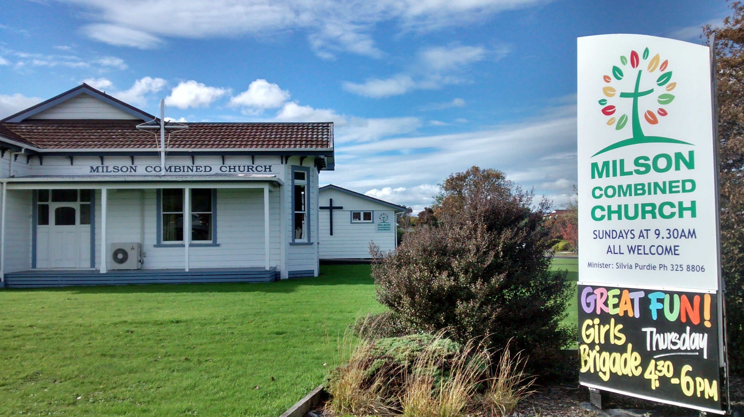
Milson Combined Church is on the main road between Palmerston North and Feilding, so everyone in both cities has driven past it heaps of times. But few people even realize it is a church! It’s that old white house on the lawn.
It’s set well back from the road, and the three doors that you can see from the road are all kept locked. To get in you need to drive round the back. So we managed to get a sign (not as big or as many as I wanted). We worked on our signage, we got a new logo. We got funding from PAC Media and Communications which was brilliant. New logos and new signs cost money and it all takes time, but it is absolutely worth it.
Talk to Kathy Glentworth from Icon Designs; she’s a lovely Christian lady who made it all easy & heavily discounted.

The next challenge is to experiment with ways to invite new people in. My little slogan is – let’s give people invitations they will welcome. These last 4 years at Milson we’ve tried all sorts of things. No one had energy for setting up new programmes or activities at other times. Our focus is clearly on inviting people on Sunday mornings. That’s when we’re there, and we want to welcome new people into our fellowship and worship on Sunday mornings. But our church folk are also willing to stick around after church for a while, so this became our main strategy for outreach. It’s easy and it’s fun. And we are good at morning teas and we love being friendly at Milson. Let’s face it – food is always the best point of welcome.

We targeted children and families. We put on Street parties,
using our lawn for bouncy castles and games. We gave away free sausages and icecreams. Here are some photos of some of our community events, … and most recently a Spring Fling which invited local community groups to participate.
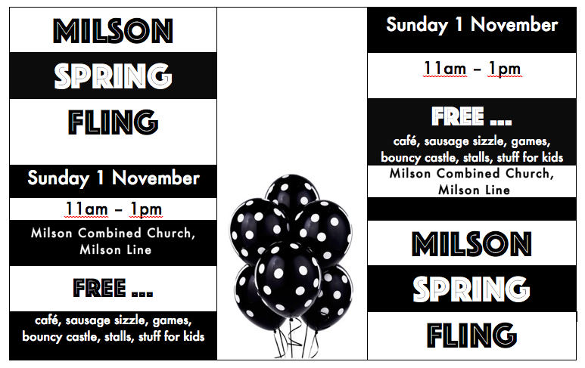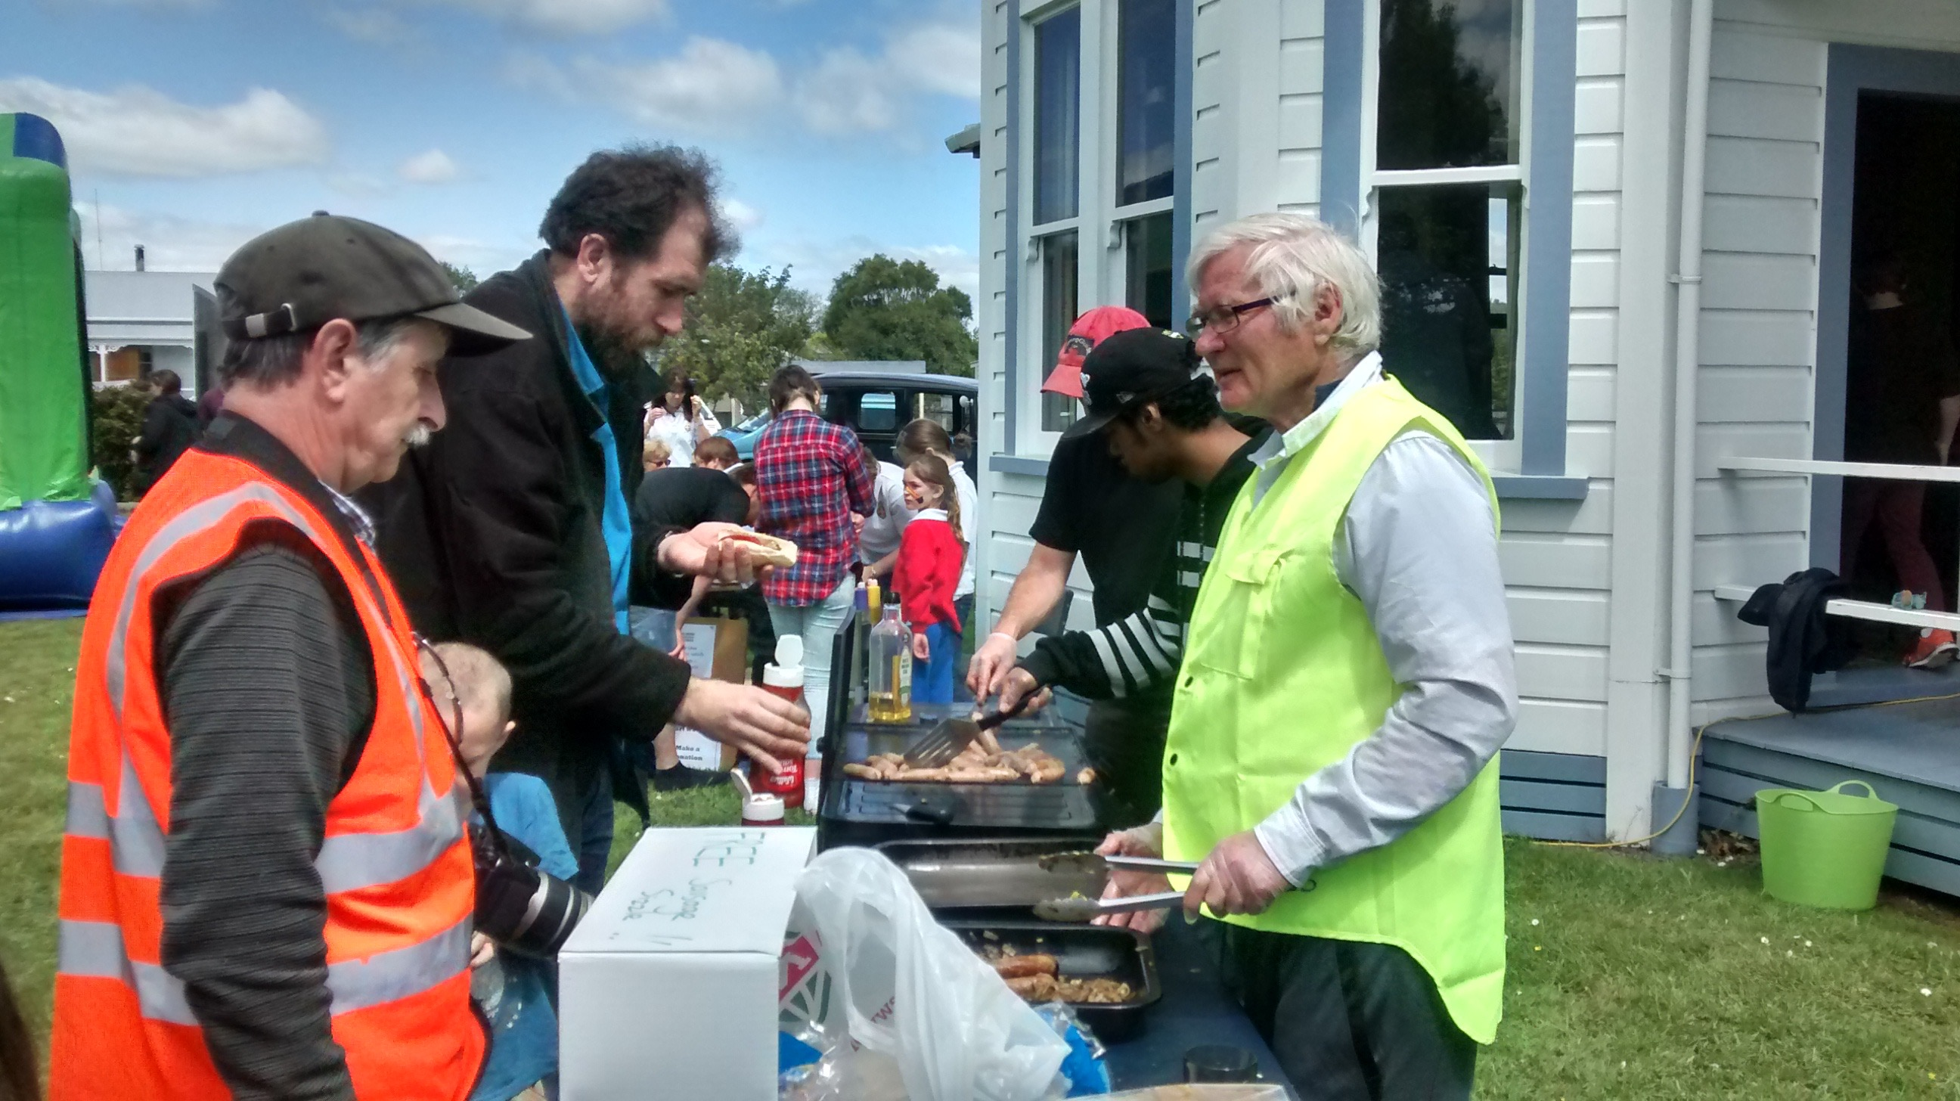
We also ran children’s programmes occasionally on a Sunday morning, like a holiday programme, for 3 hours, where kids could get signed in and dropped off.
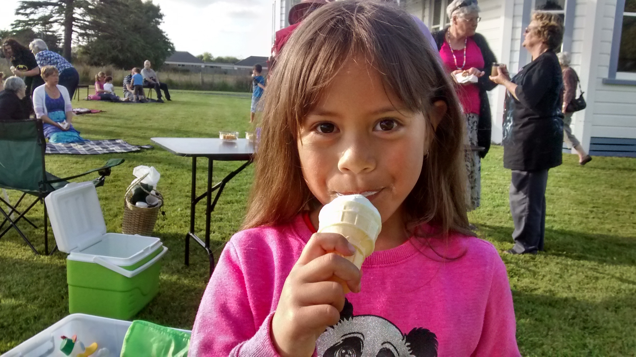I wish I had time to tell you stories about all of these but ask me more at lunchtime.
We also targeted older folk. Each year we ran a ‘Favourite Hymns and Devonshire Tea’ service
We tried extra things, for Christmas
we advertised a sermon series on topics of general interest
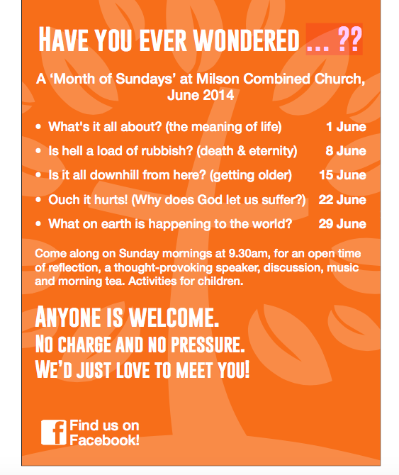
We made up letterbox fliers and delivered those.
I did some doorknocking which was a fascinating experience – not as hard as it sounds actually
We connected with local schools and early childhood centres
I tried to follow up visiting people who visited us
I have got to know the local shop keepers, and the church participated in a market day in the shopping centre carpark one freezing June day
We have made welcome packs for visitors

We developed a website:
www.milsoncombined.church.org.nz

If anyone is looking to build a website I can give you advice as to how to set this up for minimum cost. We pay a grand $5 per year for the domain registration through GodZone Internet Services a local Christian-based provider run by friends of mine. This is their (effectively free!) service for NZ churches who would like a ‘…church.org.nz’ domain address.
And our website is set up through Weebly for $40 for a year. And it’s pretty easy to put together.

One of the most important reason to get involved with community outreach is that it builds up church members. The only way to learn hospitality and generosity is to do it! I’ve seen our church folk grow in confidence that they do have important things to offer, that they can serve in various ways.
Also, people are far more likely to join a church if they see that church engaging effectively with the wider community. People are drawn to energy and momentum. Few people are looking for a church where nothing happens!

It’s all been good fun, and some things were more effective than others.
Out of this experience I would say:
1 - keep printing invitational fliers
Your best resource is your photocopier. It’s cheap and easy. You can try various colours of paper, various styles. I was particularly pleased with my Spring Fling flier. It didn’t take long to make and looks great and cost nothing.
When you have fliers your people will give them away. You can knock on a stranger’s door and offer them a flier, and hopefully get into conversation. You can leave them in libraries and hair dressers or give them out at Kindy.
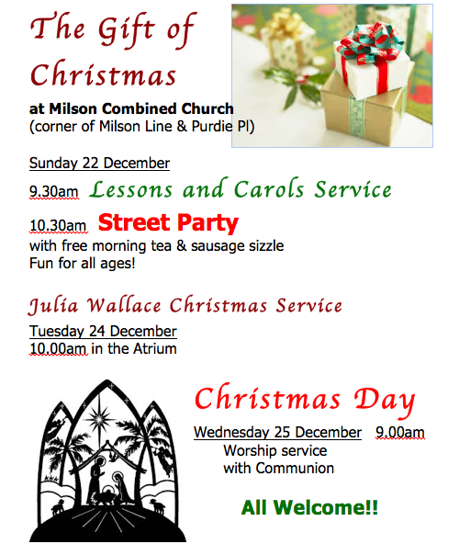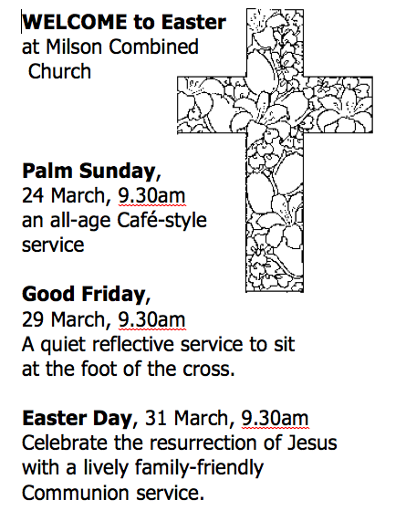

2 – review the outside of our church. Spend money on signs. Be creative with points of contact with passers by … I’m keen on blackboards, chalk on the footpath, flags, up-to-date noticeboards, murals.

3 – grow partnerships with people in your local community, and those who use your buildings. Create moments in which good old fashioned Community happens, where people feel safe just hanging out together, where people feel that they belong. These are the most precious times, and these times change the way people outside the church feel about the church. Creating community is the bridge between public and private space. We know how to do this. We just get a bit scared and tired and inward looking. We’re good at community events when we want to raise money, but my encouragement to you today is to swing wide your doors, get creative, experiment, try things out, give stuff away, tell everyone about it, offer perfect strangers invitations that they will welcome.

